**Project progress report**

Student: Paulo Borges

In the project proposition 4 steps were described in order to recognize the license plate. Image enhancement, plate location, character segmentation and character recognition. So far two extra steps were added and the two first steps are done.

1. Image acquisition: A variety of photos of license plates were taken in different locations around campus. I tried to fix a position and have a good set of photos that represents the same characteristics and I also took photos in different time of the day and light condition. Photos with completely random positions and distance were taken in order to test how robust the algorithm is.

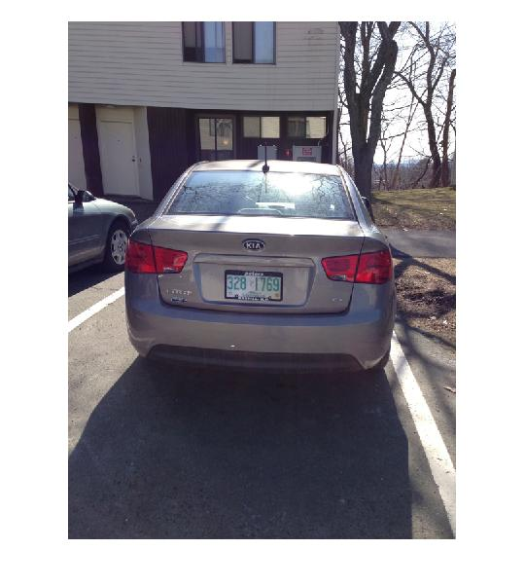 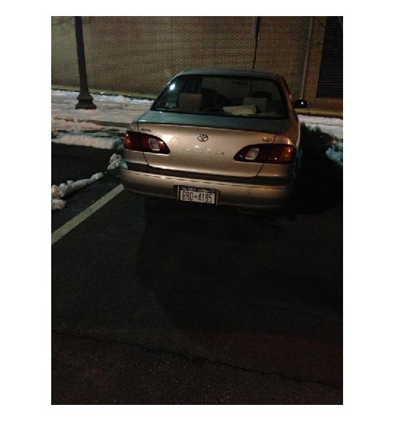

**Figure 1: Examples of images in the normal set**

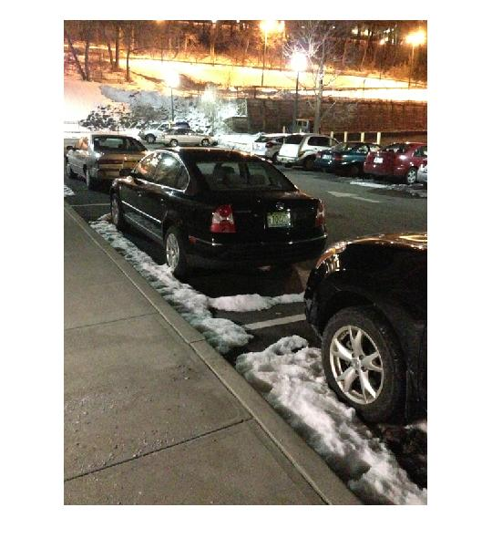

**Figure 2: Example of random parameter photo.**

1. Image enhancement: Before doing any image process to segment and recognize the license plate it was proposed to enhance the image.

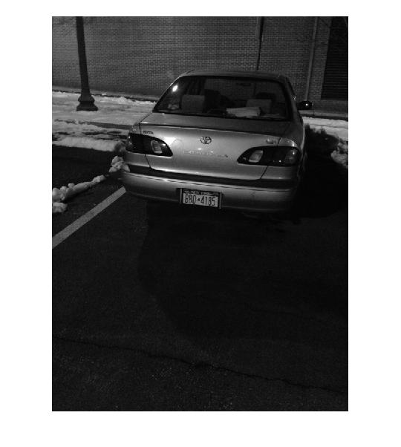

**Figure 3: Original image**

The following methods were tested:

1. Do a sobel operator in the vertical axis, [1 0 -1;2 0 -2; 1 0 -1] and add the result back to the original image creating an crisper result. However this approach is not very good because the noise, high frequency, was added back.

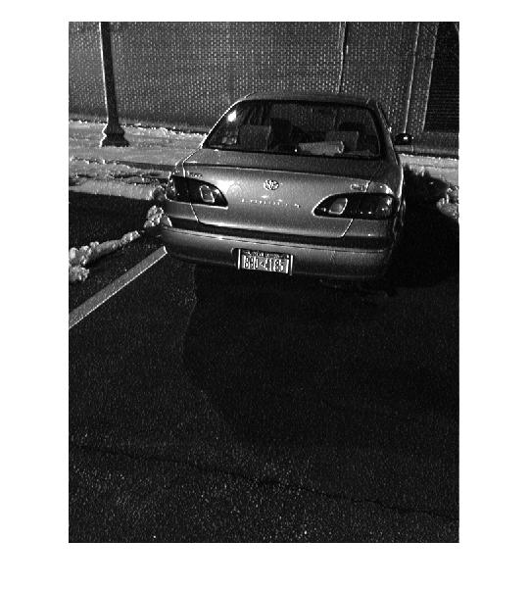

**Figure 4: Using method A of image enhancement**

1. Apply a Gaussian filter, different values of sigma, to the image after the sobel operator. The result was even worse and the characters in the plate were illegible. The image bellow is using sigma = 2

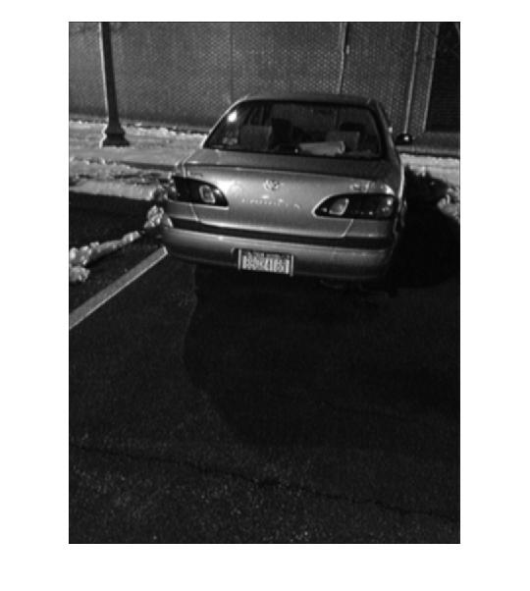

**Figure 5: Using method B of image enhancement**

1. Apply a LOG filter, this filter would reduce the noise trough a Gaussian and then enhance the edges using a Laplacian. It was used sigma = .2 and a 5x5 window. The result was good, however it changed a lot the images characteristics.

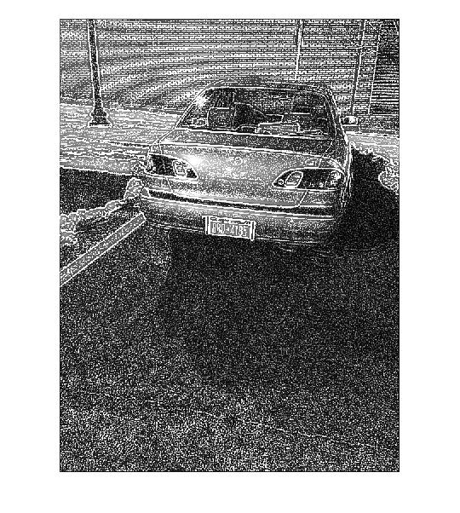

**Figure 4: Using method C of image enhancement**

1. Apply a Gaussian using sigma = 10 times the graythreshold (around 2). Then use a sobel operator to enhance the vertical axes. This approach was proposed in [3], and indeed had shown the best result.

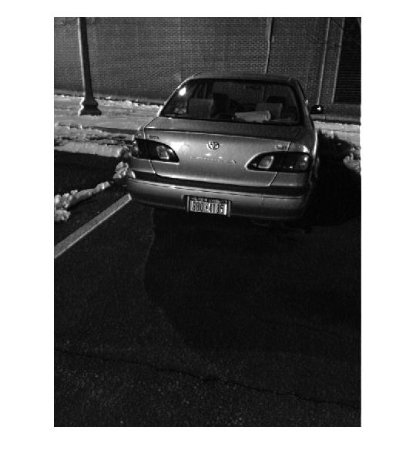

**Figure 4: Using method D of image enhancement**

1. Plate Localization: This was the most challenging step. The localization is based on a series of assumptions and constrains any change in those constrains result in a wrong result. Most of the images in the database follow the constraint of having the license plate in the central region and taken from the same angle. However there are images that were taken with random distance and angle. In the United States license plates do not follow a single pattern, each state has its own regulation and even inside the state of New York there are more than one kind of plate, becoming the implementation even harder.

The following methods were tested:

1. Image binarization followed by smearing. This methodology was described in [2]. However applying the algorithm as described in [2] didn’t result in a very good solution, this is justified because the intensity of the light in the images in the dataset varies a lot (photos were taken in different time of the day). In order to find the best solution for the set of images various combinations of parameters were tested. For the image binarization the threshold was define in a try and error approach as 0.5 of the average intensity.
2. Using only the binarization
3. Using the binarization followed by a horizontal smearing
4. Using the binarization followed by a vertical smearing
5. Using the binarization followed by a horizontal and vertical smearing

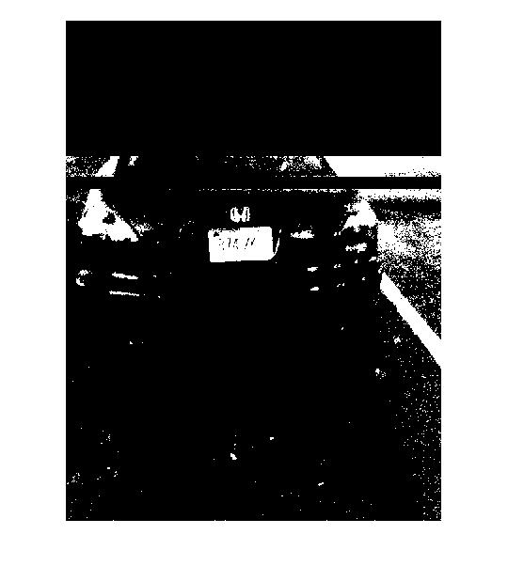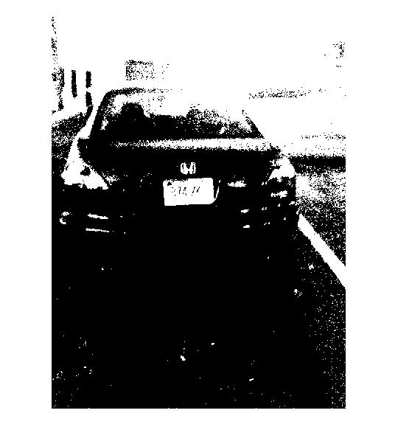

**Figure 5: Left example of only horizontal smearing and on the right only vertical**

1. Isolation: The plate localization step generates a mask, same size of the image, that ideally has 1 in the area of the plate and 0 elsewhere. However none of the localization algorithm resulted in a perfect mask for a good amount of images. Therefore this step aimed to separate the plate regions and return a collection with a reduced size matrix with only plate candidates. This step also used the area of candidate and the candidate localization as an approach to reduce the number of candidates.

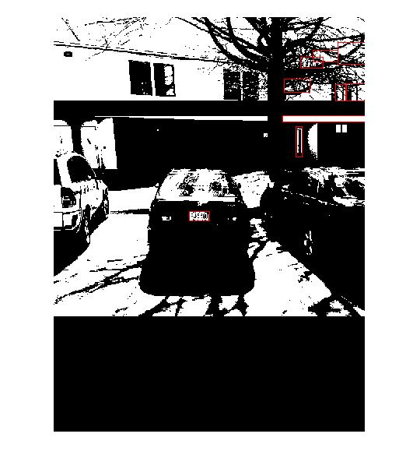 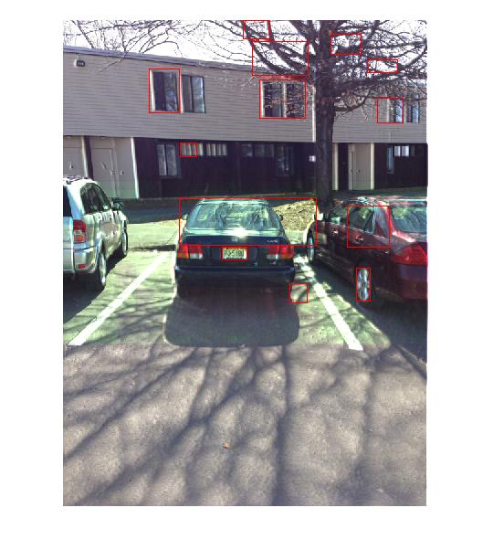

**Figure 6: Left Isolation applied to the mask, isolation applied to the enhanced image**

In order to perform this step the bwlabel command was used in matlab, this command receives a binary matrix and returns an integer matrix of connected components.

The result is the following table. I consider if the plate region is shown, even thought there are other regions showing in the image, as a hit. The average number of candidates generated for each image is also shown in the following table.

|  |  |  |  |  |
| --- | --- | --- | --- | --- |
| Algorithm | Result using a fixed set | Result using a random set | Result using a fixed set with previous enhance | Result using a random set with previous enhance |
| Mask A | 80% - 20 | 60 % - 10 | 80 % - 8 | 60 % - 10 |
| Mask B | 70% - 15 | 50% - 8 | 70 % - 7 | 50 % - 12 |
| Mask C | 60% - 12 | 60% - 12 | 50 % - 10 | 50 % - 3 |
| Mask D | 90% - 4 | 40% - 6 | 90% - 5 | 40% - 7 |
| Direct Image | 60% - 19 | 30% - 20 | 80% - 18 | 40% - 20 |

**REFERENCE**

[1]http://users.utcluj.ro/~rdanescu/proiecte/01-licenseplate.pdf

[2]http://pdf.aminer.org/000/349/486/gray_scale_character_recognition_by_gabor_jets_projection.pdf

[3] http://ac.els-cdn.com/S0167865505001406/1-s2.0-S0167865505001406-main.pdf?_tid=acdf9518-8985-11e2-adb3-00000aacb35f&acdnat=1362921979_902d579f2e482404e4439330e451c25b

[4] http://www.itfrindia.org/ICCIC/Vol2/9024ICCIC.pdf

**The code developed so far is available in:** https://dl.dropboxusercontent.com/u/12099589/License%20Plate%20Code.zip